IELTS Writing Task 1 Pie Chart Sample #01

The charts show the sources of electricity produced in 4 countries between 2003 and 2008.Summarise the information by selecting and reporting the main features, and make [comparison](https://zim.vn/cac-cau-truc-so-sanh-trong-tieng-anh-va-ung-dung-vao-ielts-writing)s where relevant.

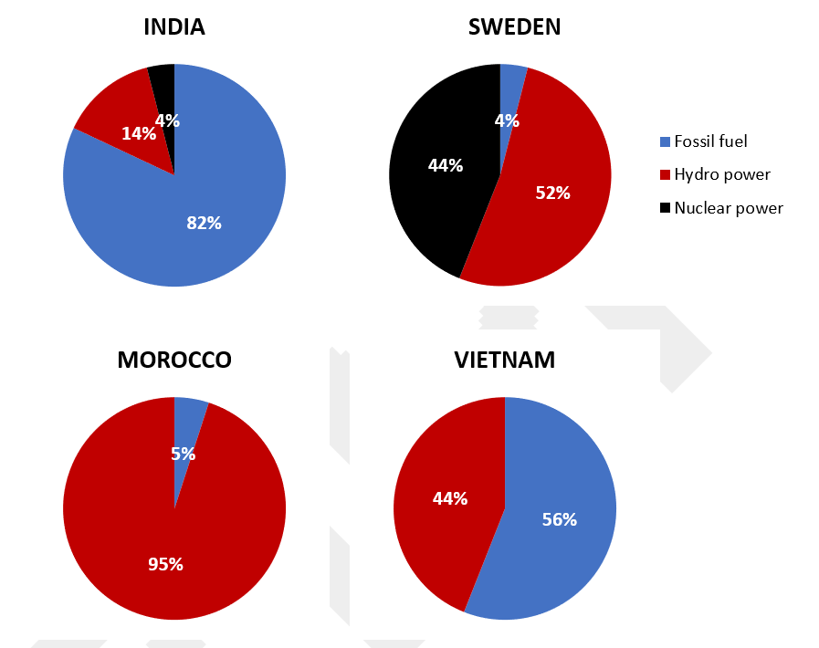*Bài viết mẫu biểu đồ trong IELTS*

IELTS Writing Task 1 Pie Chart Sample

The given pie charts detail information about the proportion of/the percentage of three different sources of electricity in four countries (India, Sweden, Morocco and Vietnam) from 2003 to 2008.

**Overall**, Vietnam and Morocco did not use any nuclear power for electricity production. It can also be seen that while fossil fuels were the largest source of electricity supply in Vietnam and India, they only occupied a relatively marginal proportion in Morocco and Sweden during the examined years.

In Vietnam, 56% of the total amount of electricity was produced from fossil fuels, while the figure for Morocco was only 5%. The rest of the electricity, in both nations, was produced solely from hydro power.

In India however, electricity from fossil fuels contributed to 82% of the entire quantity of electricity produced, which was also the highest figure for fossil fuel use among the four countries. Meanwhile, fossil fuels were only responsible for 4% of the total generated electricity in Sweden, with hydro power and nuclear power contributing 52% and 44% respectively.